**Capstone Project – The Battle of Neighborhoods**

Diep, Ly Bao Long

1. **Introduction/ Business Problem**
2. **Background**

* It is undeniable that Canada is one of the worth-living countries all over the world because of having diverse ethnicity and offering a whole host of great opportunities for immigrants to develop. Significantly, Toronto and Vancouver have gained the reputation for being the two main economic cities in Ontario province and it is evident that these cities have a high standard of living and employment rate, making it very attractive and commonplace to inhabit down the road. Since Toronto and Vancouver are famous metropolitan areas, there has been a bunch of comprehensive analyses and surveys about them, and they will not be on the agenda of this project. As regards the ideal living areas, I will pay my attention to the other cities in Canada, particularly London city which is part of Ontario province and one of the potential candidate cities. Dissimilarly, London is a city with a moderate area of about 420.6 km2 in the southern part of Ontario. More intriguing, London is not densely populated, and it is estimated that the total population is approximately 404,699 in 2017 compared to 2.93 million in Toronto in 2017, which will contribute to reducing the severe competition in job markets. Moreover, the economic resources and wealth in London primarily derive from medical research, education, insurance, and information technology which demonstrates that London also has good social welfare to attract newcomers, and sufficiently creates a whole host of employment opportunities with prospective promotions to nourish and foster an abundant workforce. Thanks to these good social and living factors, London can be considered to meet several standard living conditions at least. The overview about London has been listed out, but another issue which is also far more important to deal with is which neighborhood in London is the best to settle down and initiate a business.

1. **Problem**

* **Problem definition:** Accommodation and start-up problem in London, Ontario.
* **Circumstance:** In this capstone, as an upcoming data scientist, I will reach out to stakeholders who are looking for a living area which is convenient and well-located with good public amenities and service in London, Ontario. Specifically, we are going to explore the neighborhoods and specify the number of ideal residential areas in London. What’s more, the stakeholders also have no clue for what kind of effective business patterns they should initiate, so they need some handy suggestions for some potential businesses in the recommended areas.
* **Assumption:** It is obvious that there are a number of influential factors such as the stakeholder's affordability for the cost of living and the price of the real estate in the desired areas. Since this capstone primarily focus on using Foursquare to discover the most fantastic living area in this capstone, it will be assumed that these factors are in the available budget of the stakeholders.
* A data scientist will manipulate the power of data to generate the most feasible and promising neighborhoods based on the listed above criteria. It will be expected that the upsides and downsides will be also comprehensively laid out so that the best deliverables can be used to help the stakeholders make their final decision.

**\*\* Agenda \*\***

* What neighborhood is the best to settle down in London, Ontario?
* How far is it from the living area to its surrounded venues?
* What kind of potential business pattern should be recommended?

1. **Target Audience**

* This project will significantly draw the attention of the potential stakeholders who have a desire to settle down in a second homeland and run their own business in a residential area with good living conditions. To be more precise, the stakeholders can be tenants, new immigrants, real estate companies, international settlers, home investors, etc.

1. **Data acquisition and cleaning**
2. **Data Collection**

* Based on the defined circumstance, there will be a number of factors that will have impacts on the decisions and analyses:
* The number of neighborhoods that need to be taken a look at in London, Ontario.
* The distance from the living areas to the other venues within the scope of neighborhood.
* The number of available business patterns within the neighborhood.
* As listed above, the following data sources will be needed to generate the required information:
* The location and coordinates of each neighborhood in London, Ontario will be scraped from [**http://www.geonames.org/postalcode-search.html?q=london&country=CA&adminCode1=ON&fbclid=IwAR2XipWkuSm3F9YSjjVvFqp7SfYCPl9_XaxiehoPnn-7XmsjtnJBrbKh31g**](http://www.geonames.org/postalcode-search.html?q=london&country=CA&adminCode1=ON&fbclid=IwAR2XipWkuSm3F9YSjjVvFqp7SfYCPl9_XaxiehoPnn-7XmsjtnJBrbKh31g) by using **Pandas function/ BeautifulSoup**.
* The number of venues and their categories within each neighborhood are extracted by using **FourSquare API**.
* **The extracted venue categories** can be used as a **separated dataset** to build the **recommender system** for the suggestion of business patterns.

1. **Data Refinement and Formatting.**

* Since the required data scraping from the available dataset on webpage is originally raw, some data transformation and refinement will have to be carried out for the easily visual analysis and exploration.
* The dataset used in this analysis should be in tabular form and consist of a number of following columns: **Postal Code, Borough, Neighborhood, Latitude, Longitude.**

**Sample table:**

|  |  |  |  |  |  |
| --- | --- | --- | --- | --- | --- |
|  | **Postal Code** | **Borough** | **Neighborhood** | **Latitude** | **Longitude** |
| 1 |  |  |  |  |  |
| n |  |  |  |  |  |

* Each row contains different data values corresponding to each column.

**Illustration for the original dataset**

* 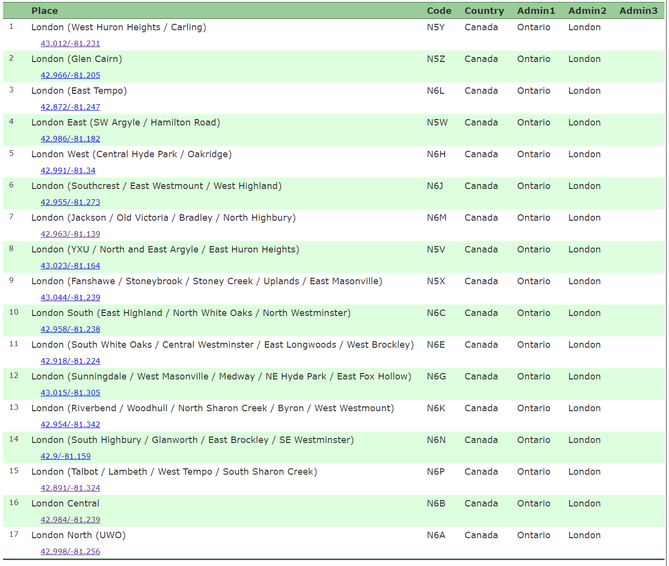As shown by the data table above, each individual row is filled with distinct data, but it is not in the desired form which is mentioned above. More significantly, the “Place” column seems to be messy because one labelled row contains not only the combination of borough and its neighborhood enclosed in parenthesis but also its latitude and longitude right in the unlabelled row below. The “Code” columns will be converted into the “Postal Code” column and the rest of the columns are not requisite and will be eliminated.
* **BeautifulSoup** library will be the efficient and easy-to-use tool in scraping this dataset. The rows containing the combination of borough and neighborhood will be separately derived and converted into two distinct columns (Borough and Neighborhood). Similarly, the coordinate values in the unlabelled rows will be also separated into two numeric columns (Latitude, Longitude).
* Finishing filtering out the above dataset, we have a complete refined data table, and it is ready to be used in the next stage of analytic process.

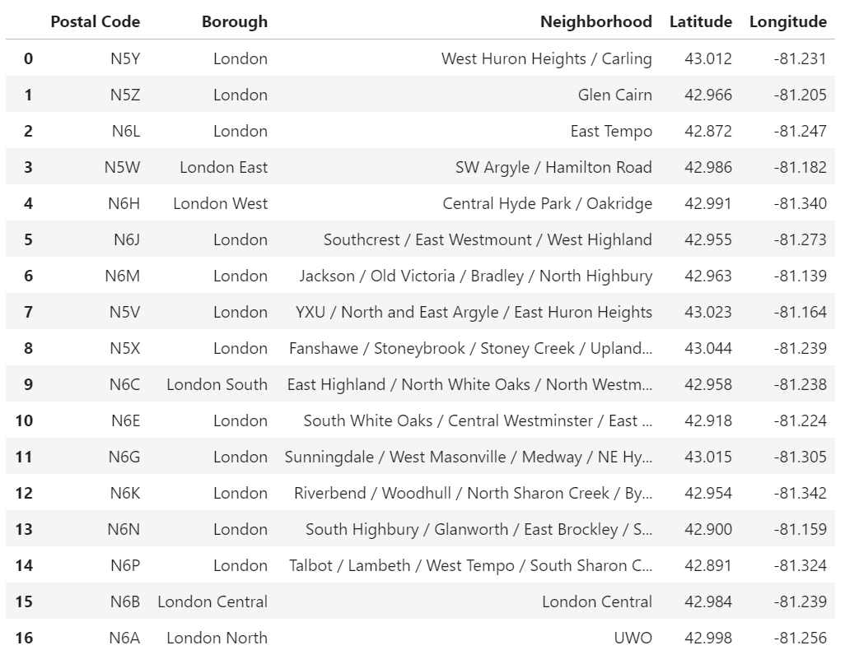**\*\*NOTE**:** There are **17 obtained neighborhoods** in London, Ontario in total.

1. **Methodology**

* Data visualization, data exploration, data analysis and any machine learning methods utilizing for making recommendation will be comprehensively performed in this section.
* Since the required dataset for the neighborhoods in London have been thoroughly gathered **(postal code, borough, neighborhood, latitude, and longitude)**, the exploration of venues within **the radius of 1000 meters** from the default coordinate of neighborhoods can be carried out by using **Foursquare API.**
* Firstly, to make the analytic process more insightful, the **Folium package** will be utilized for the visualization of the geographic positions of all the neighborhoods in London.
* The second step of the analysis will be **the calculation and exploration of** **the distribution of venue categories** across different areas of London. The analysis will mainly focus on the most promising areas and within those create different clusters of neighborhoods that meet some basic requirements established in the discussion with stakeholders:
  1. Considering the areas with **\*\*high density in the scatter of venues and the diversity of venue categories**\*\*.
  2. Presenting a geographic map of all such locations and creating clusters (applying \***\*k-means clustering\*\*** of Machine Learning) of those locations to identify the candidate neighborhoods based on their similarity and dissimilarity and search for optimal areas.
* In the next step, the recommendation system for the trustworthy candidates will be built based on the exploratory venues within different neighborhoods in London. In addition, the use of the Toronto dataset as an additional reference is to make a comparison between the venue categories in both cities so that the business patterns which have never been exploited in London can be taken into consideration for the recommendation.
* Finally, the optimal solution will be ready to handle the stakeholder's problems.
  1. **Data Visualization**

Map of neighborhoods in London

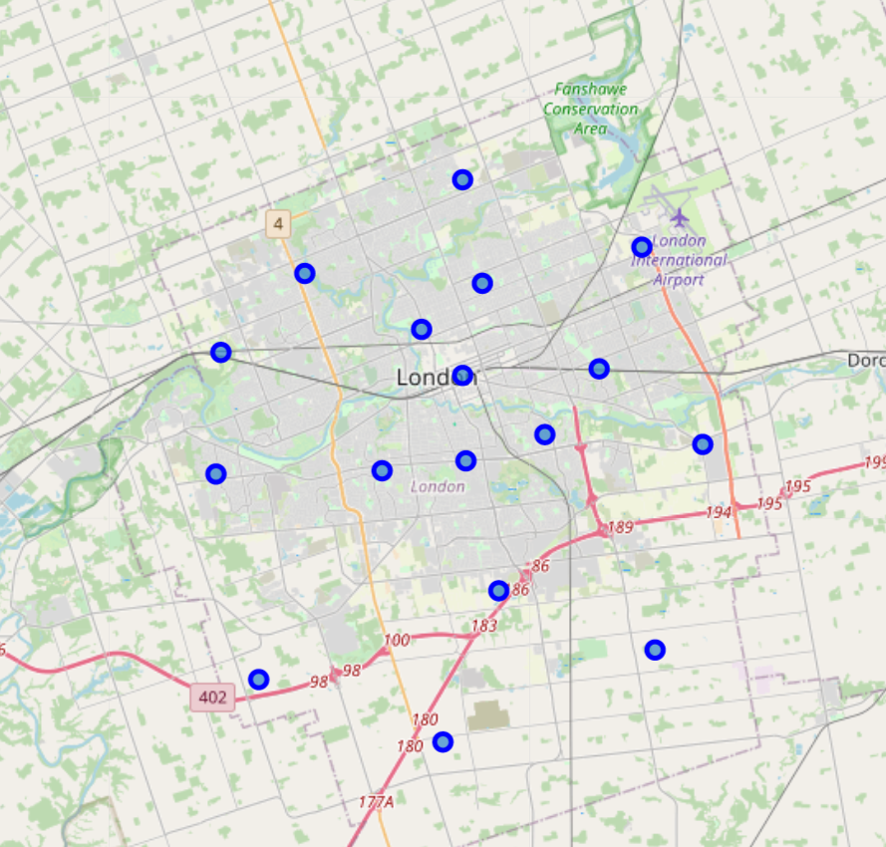

* The default geographic coordinates of London city are 42.9836747, -81.2496068.
* Glancing at the above map, it is remarkable that the distribution of neighborhoods becomes denser and denser when it gradually exposes to the central area of London. According to this observation, it is predicted that there will be more exploratory venues within the closer neighborhoods rather than the ones which are located in or near the outskirt of London city.
  1. **Data Exploration**
* Foursquare application:
* Since the main purpose of this project is to optimize the useful application of Foursquare API which is one of the most handy and powerful Application Programming Interface tools for the geographic exploration, the utility of Foursquare will be fully exploited in the exploratory process. Now, the number of local venues in each individual neighborhood will be completely investigating.
* The neighborhood investigation only occurs within the limited radius which is set to 1000 meters from the center of the neighborhood.
* To get the venue data of each neighborhood from Foursquare, the unique client information (ID, Access Token) and the available coordinate (latitude, longitude) of each neighborhood are requisite, but the more technical part of how to create and use Foursquare API will not be mentioned here, only the final result after the neighborhood exploration. It is remarkable that the Foursquare will basically make use of the latitude and longitude of the designated area to detect the approachable local venues within the limited radius.
* At the end of the neighborhood detection, the expected data’s features that have to be captured for the later analysis will be the name of venues, the venue latitude, the venue longitude, and the venue categories.
* Illustration for the exploration:

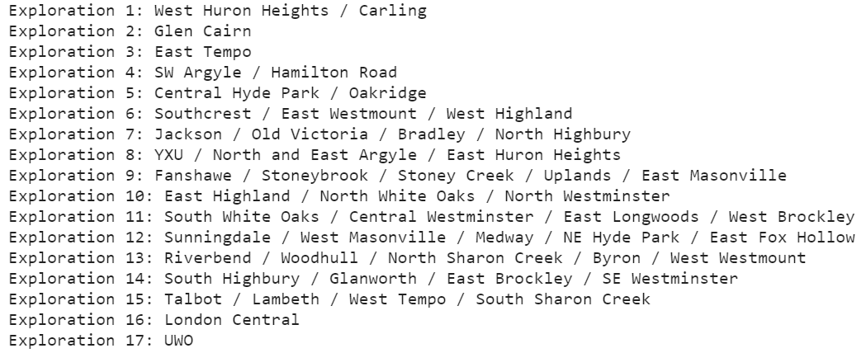

* 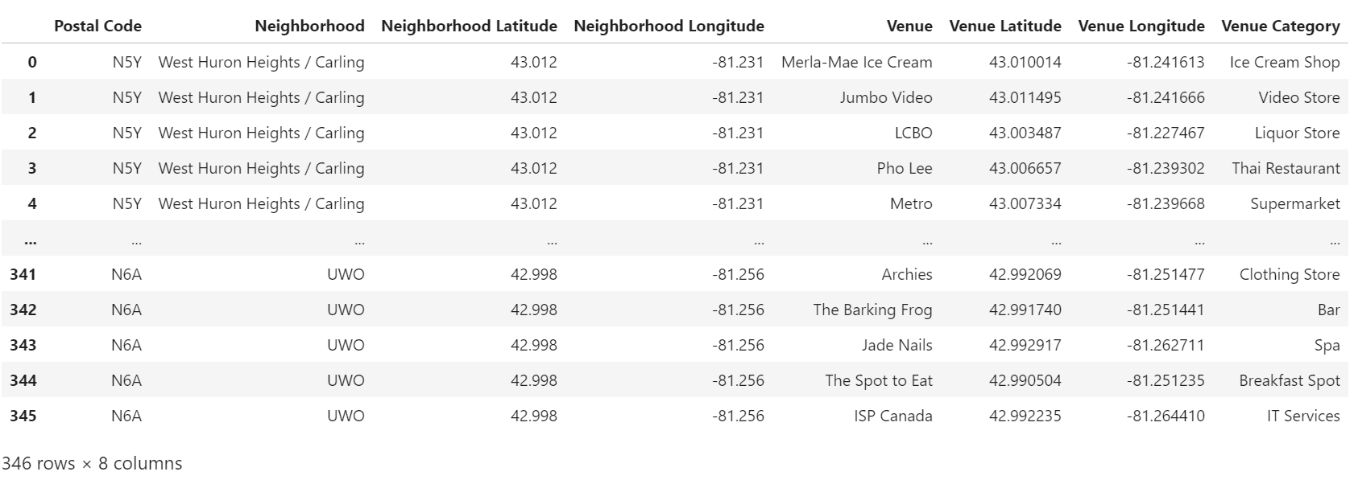Illustration for the expected result:
* Observably, the Foursquare has done 17 neighborhood explorations based on 17 neighborhoods and after the neighborhood investigation, there are 346 rows containing the exploratory venues of different neighborhoods and 8 columns containing the venues’ corresponding features. However, this result table is messy, and it will be very arduous and time-consuming to accumulate and examine the total number of venues that one neighborhood has as there is a whole host of exploratory venues in one distinct neighborhood.
* To have a more visual overview after the exploration, each venue will be grouped by their corresponding Postal Code and Neighborhood.
* Categorical table

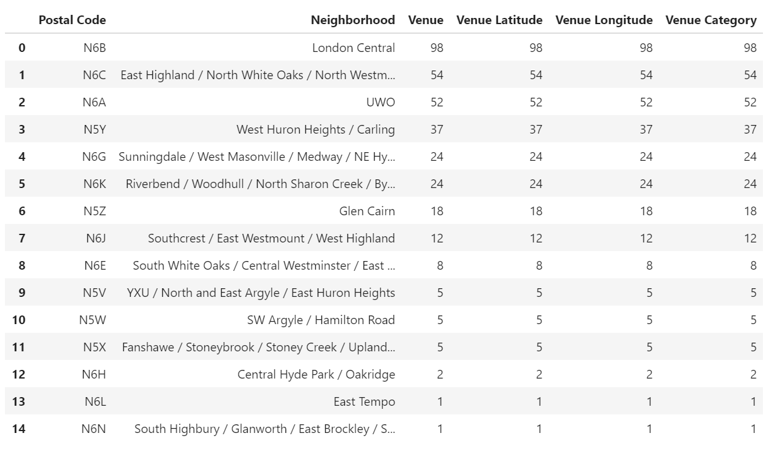

* The above data table actually gives a more profound visualization for the neighborhood exploration. Applying coding will give the summation result of 120 unique venue categories which are approachable in London.
* Looking at the illustration above, there are a number of significant points:
  1. **Missing neighborhoods/ Outliers.**
* There are only 15 neighborhoods with approachable local venues left after the exploratory process while 17 neighborhoods have been examined in the neighborhood exploration. There are two missing neighborhoods, which are N6M, N6P.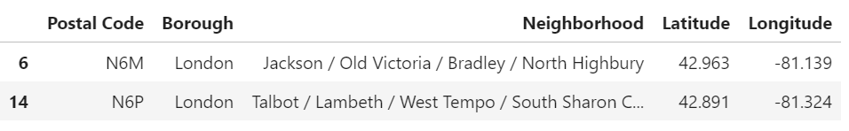
* It is evident that there is no approachable venue that can be detected within the limited radius from the neighborhoods with the postal code N6M and N6P. These two missing neighborhoods can be considered as outliers from the others because of not providing the expected information and meeting the criteria mentioned in this project and are eliminated from the candidate list because of the inadequate standard for the next analysis.
* Only 15 remaining candidate areas will be taken into consideration and it is expected that the most promising living areas in London, Ontario can be discovered at the end.
  1. **Neighborhood with sparse venue density**
* Some neighborhoods are extremely poor in the number of approachable local venues, which are N6E, N5V, N5W, N5X, N6H, N6L, and N6N. Nevertheless, it is advantageous that these neighborhoods can be potentially got rid of the candidate list in the long run due to being unqualified, so the best ones will be unearthed.
  1. **Data Analysis**
* In this section, the analytic techniques, mathematic calculations, and machine learning algorithms served to perform statistic testing for the analysis will be comprehensively elaborated. To be more specific, the key methods include the one-hot coding technique, K-Means clustering (ML), and 2D Cartesian distance calculation.
  1. **One-hot coding**
* It is sometimes unknown that the “One-hot Coding” is one of the most efficient and easy-to-use techniques which can perform the conversion between the multiple categories or sorts which are in string values and categorical values which are in numeric format (1 if the category is available, otherwise 0).
* As indicated by the categorical table above, there are numerous venue categories detected in one neighborhood, so the application of “One-hot Coding” method will give an overall observation of venue categories which are accessible in a neighborhood.

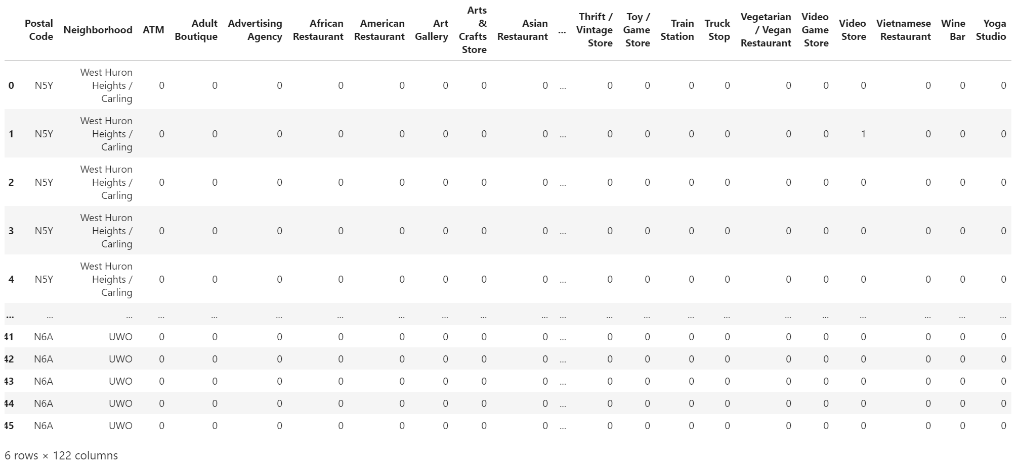

* The “One-hot Coding” table depicts 346 rows standing for different available categorical values of each venue and 122 columns will be the categorical features.
* At this point, the inquiry of how frequently the presence of a venue category will be in a neighborhood will be what have to be resolved. In other words, the frequency/ frequency distribution scores of each venue category need to be computed. The calculation of frequency score is fundamentally the mean/ average of the total categorical values of one venue category divided by the total number of venue categories in one neighborhood. This mean ratio indicates the frequent proportion (the quantity/ the distribution) of one venue category within its neighborhood. The greater the ratio is, the greater number of one venue category in a neighborhood.
* Frequency/ Frequency distribution score.

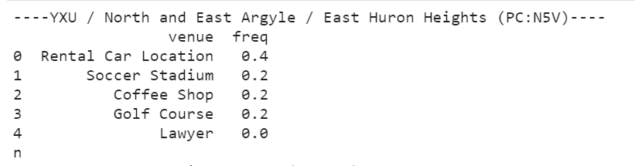

* 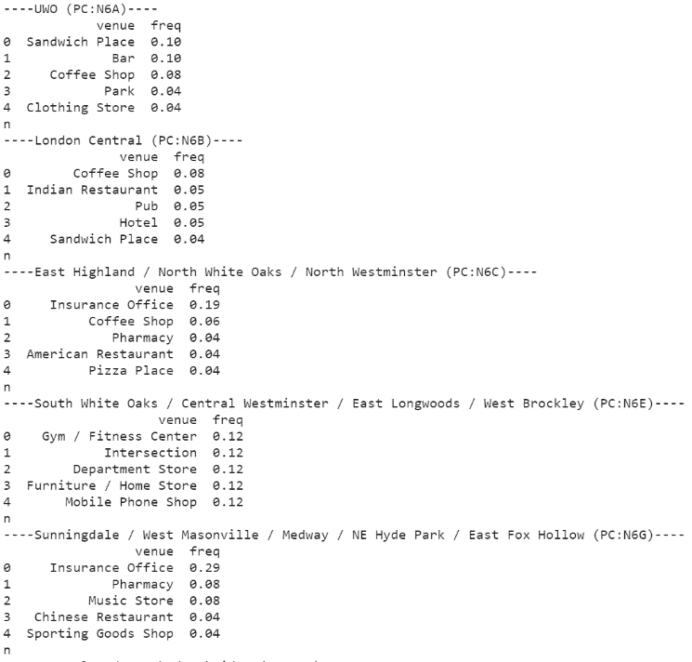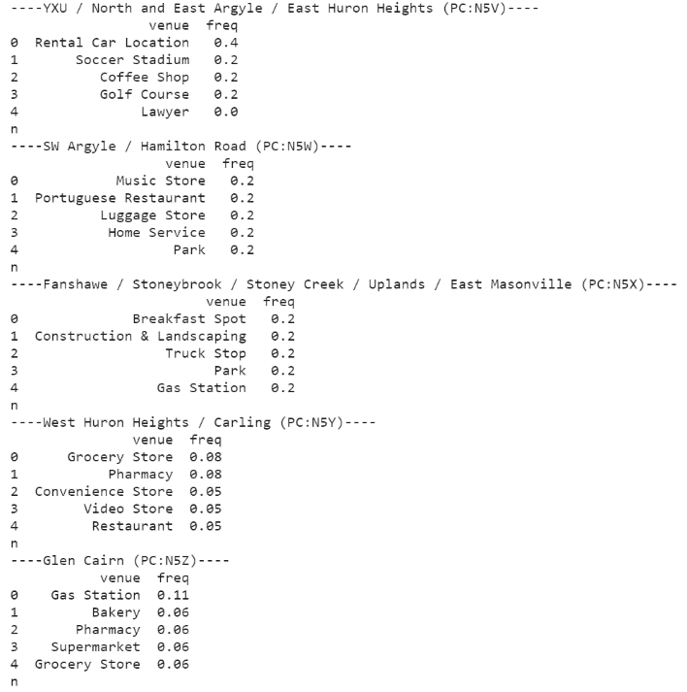Looking at the first row of the venue (row 0), the venue category with “Rental Car Location” has the highest frequency distribution score, demonstrating that there will be lots of venues that provide rental car services in the area of YXU / North and East Argyle / East Huron Heights. It is significant that the lowest score is equal to 0, implying that there is no lawyer office located in the neighborhood with the postal code, N5V. In general, the area with the postal code, N5V, has only 4 approachable venue categories, which reveals the minor number in the distribution of venue categories in this area.
* 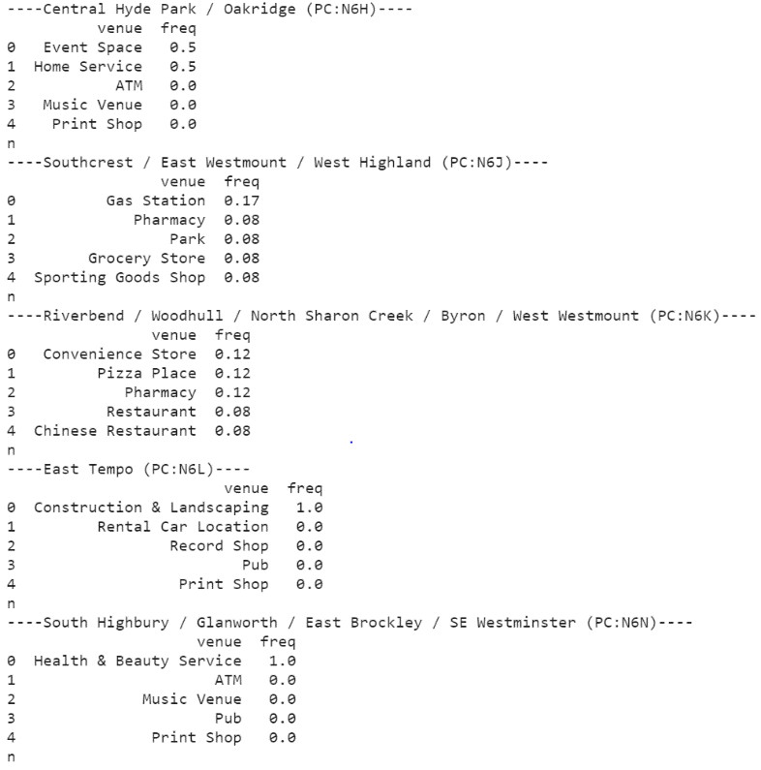Thoroughly observing the above the frequency distribution score of all venue categories of the neighborhoods, some remarkable points are found:
* A number of potential candidate areas with a variety of venue categories.
* Unqualified neighborhoods which are hardly diverse in the distribution of venue categories.
* The top popular venue categories which are based on the frequency distribution score sorted in the descending order.
* Subsequently, only the most 10 commonplace venues categories are extracted for the candidate examination. This is a sub-step before getting into the more mathematic analysis.

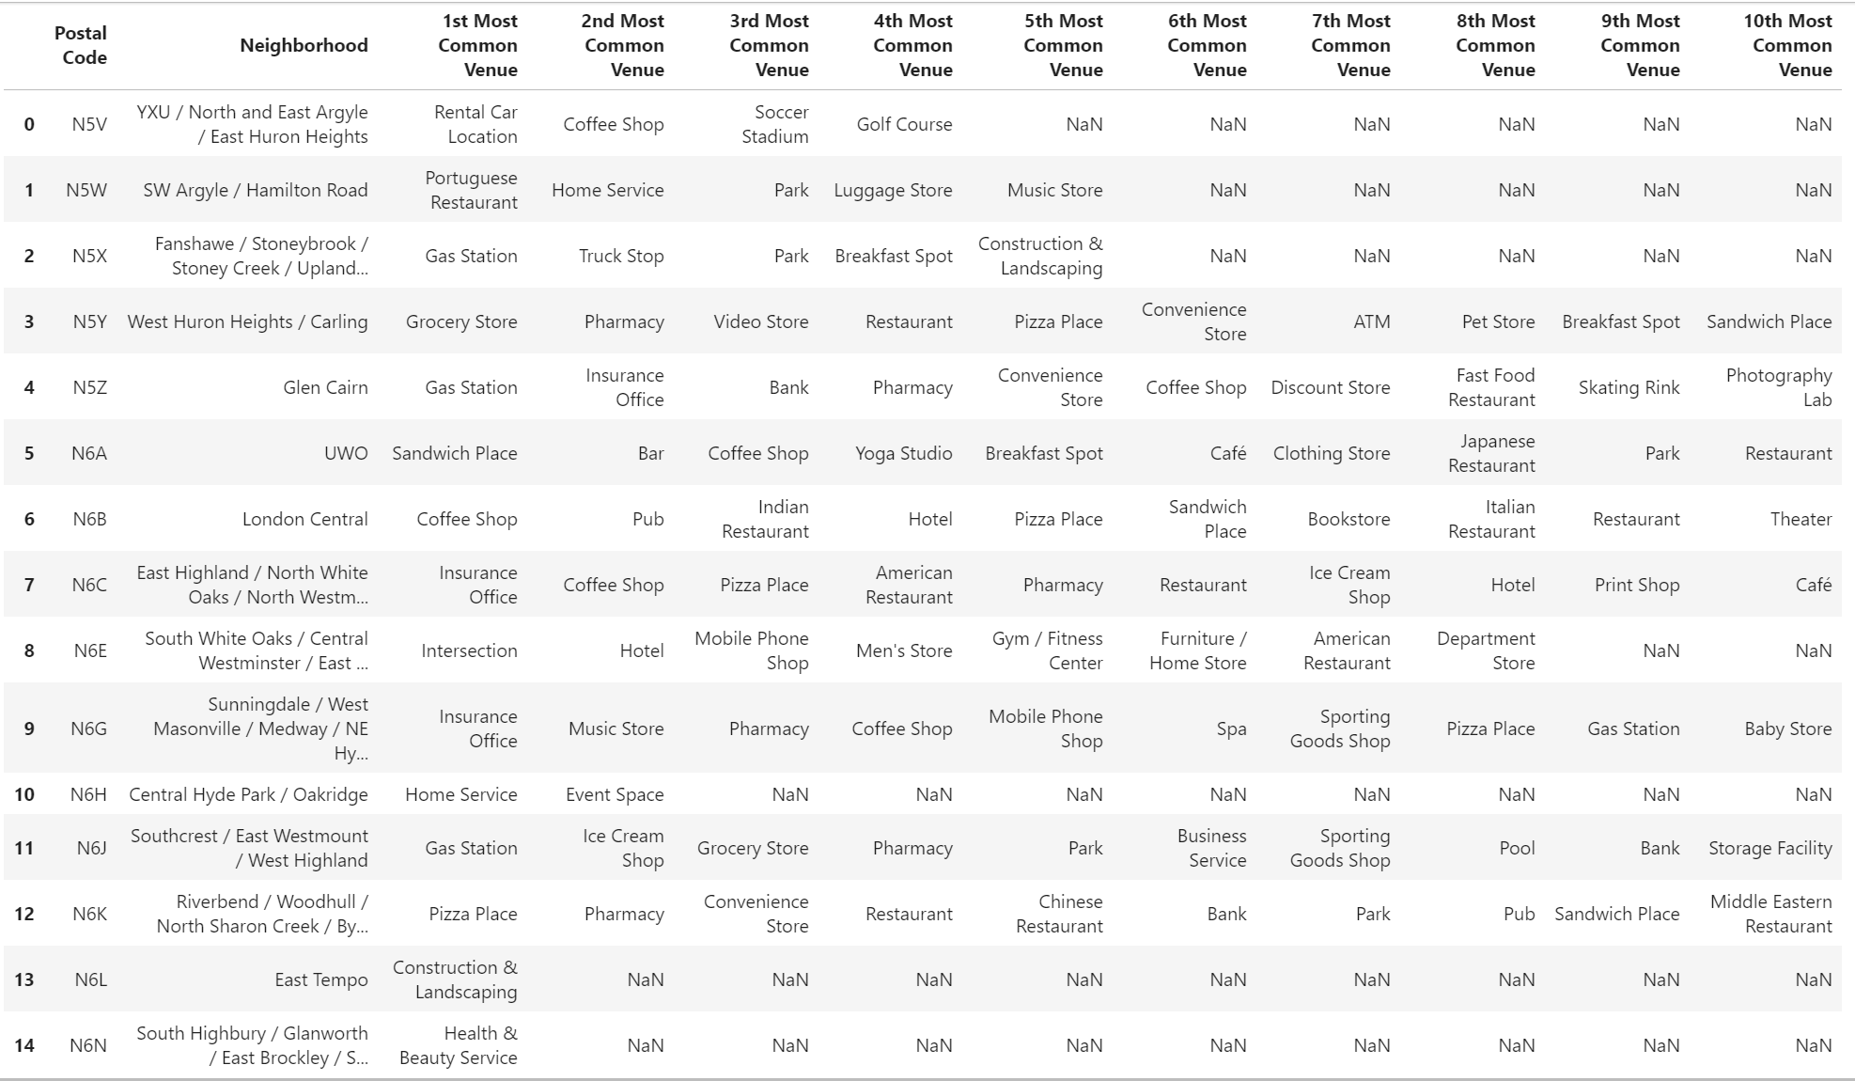

**Personal observation:** it is discernible that several neighborhoods have a diverse distribution in venue categories, but it is also easy to notice that some areas which contain NaN values (unavailable data) are sparse in the number of accessible venue categories such as N6L, N6N, N6H, N5V, N5W, and N5X, which do not meet the required criteria. Undoubtedly, these unqualified neighborhoods can be potentially got rid of from the candidate list later. To be more exact, a clustering method, K-Means, which is an algorithm of Machine Learning will be taken into practice to identify the potential candidate.

* 1. **K-Means clustering**
* K-Means is an unsupervised learning method of machine learning. The primary purpose of utilizing K-Means is to partition the neighborhoods into a number of k clusters based on the similarity and dissimilarity so that the trustworthy candidates can be detected. However, the flaw of K-Means is that it requires a number of k initial random centroids (clusters) for the features of the given dataset, but it is very challenging to get the best k number for the optimal results.
* Fortunately, the elbow method can solve all of this problem. Firstly, the estimated interval for the k initial clusters will be set from 1 to 11 for the elbow testing. A visual graph will be needed in this circumstance.

Elbow diagram

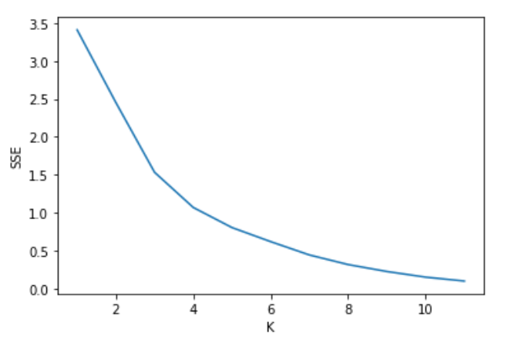

* In the elbow diagram above, the horizontal axis represents the number of k from 1 to 11, and the vertical axis indicates the Sum of Squared Error (SSE). Observing the sketched plot above, it is discernible that the Sum of Squared Error keeps decreasing while the K number is increasing. The point at which the drew line is greatly bent is equal to 4. This is the elbow of the line at the point with k = 4. This also interpret the functionality of how the elbow method. The dataset containing potential candidate areas will be divided into 4 clusters. Then, the feature data that is the the frequency distribution score of all venue categories of each neighborhoods will be plugged into the training process of K-Means. As a result, 15 labelled clusters are obtained after the training corresponding to 15 neighborhoods. Now, each different area in London has its own label. The labels actually reveal the clusters/ groups to which the neighborhoods with similarity in venue categories belong. The neighborhoods with the same labels will be partitioned into the same clusters.
* **Cluster Label Table**

|  |  |  |  |  |  |  |  |  |  |  |  |  |  |  |  |
| --- | --- | --- | --- | --- | --- | --- | --- | --- | --- | --- | --- | --- | --- | --- | --- |
| Postal  Code | **N5Y** | **N5Z** | **N6L** | **N5W** | **N6H** | **N6J** | **N5V** | **N5X** | **N6C** | **N6E** | **N6G** | **N6K** | **N6N** | **N6B** | **N6A** |
| Cluster  labels | 0 | 0 | 1 | 0 | 3 | 0 | 0 | 0 | 0 | 0 | 0 | 0 | 2 | 0 | 0 |

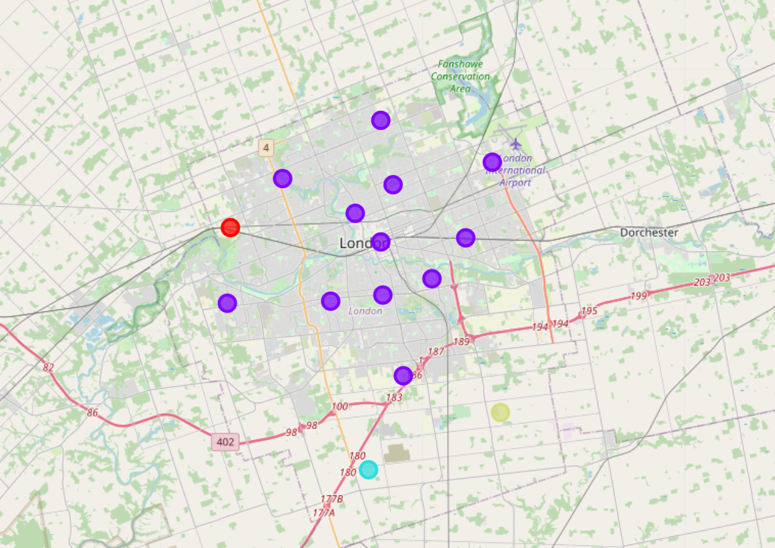

**Cluster 0**: 11 neighborhoods **(purple)**. **Cluster 1**: 1 neighborhood **(teal)**. **Cluster 2**: 1 neighborhood **(green)**. **Cluster 3:** 1 neighborhood **(red)**.

* As indicated by the cluster label table, there are 4 unique cluster labels in total, and cluster 0 is the most outstanding cluster among the others with a great number of neighborhoods, promising that the prospective candidates will be in cluster 0. To be more precise, the neighborhoods in each different cluster will be examined individually.
* **Cluster analysis**

**Cluster 3**

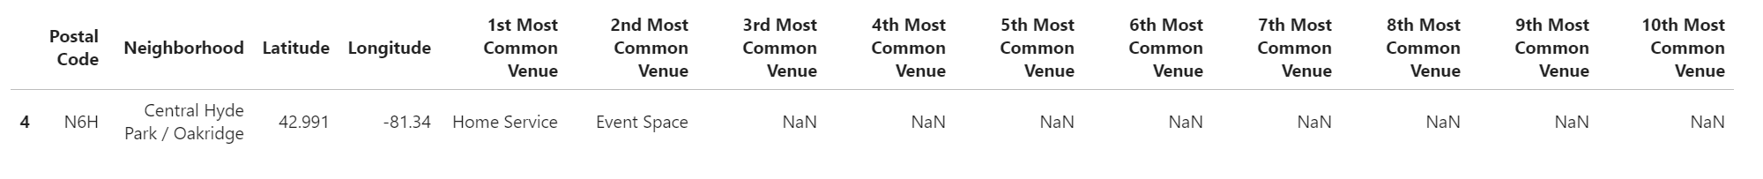

**Cluster 2**

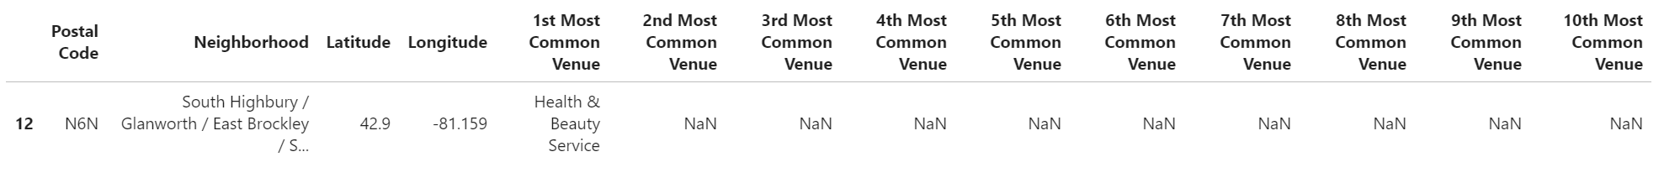

**Cluster 1**



**Cluster 0**

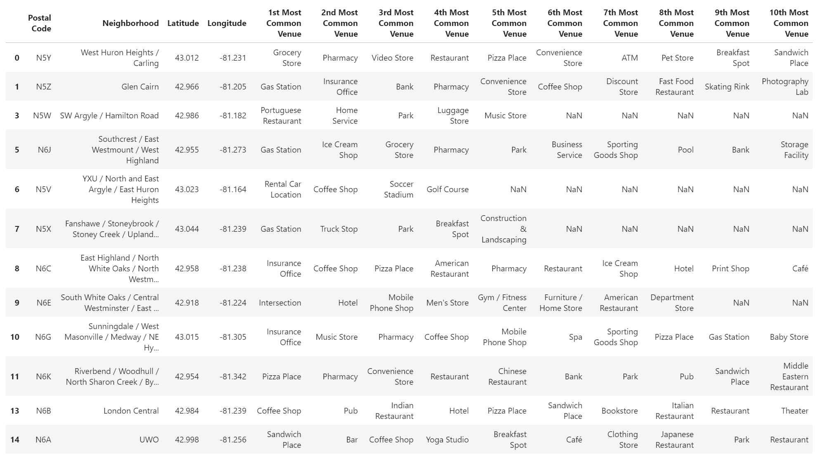

* According to the illustration above, it is evident that the neighborhood distribution of the purple cluster (cluster 0) outweighs the other clusters. More crucially, most of the neighborhoods in cluster 0 have more than 4 accessible venue categories while the other clusters mark the neighborhoods which are extremely restricted venue categories. This empowers the analysts to not only get rid of the neighborhoods with poor venue distribution but also achieve a number of potential areas which have a variety of venue categories.
* Undeniably, K-Means has contributed to filtering out the cluster with promising candidates, particularly cluster 0. However, the final objectives in this analysis mainly aim to the neighborhoods which has as many diverse venue categories as possible. Hence, the neighborhoods lacking the diversity in venue distribution will be out of the scope. The complete refined candidate list contains only 8 neighborhoods.

Candidate list

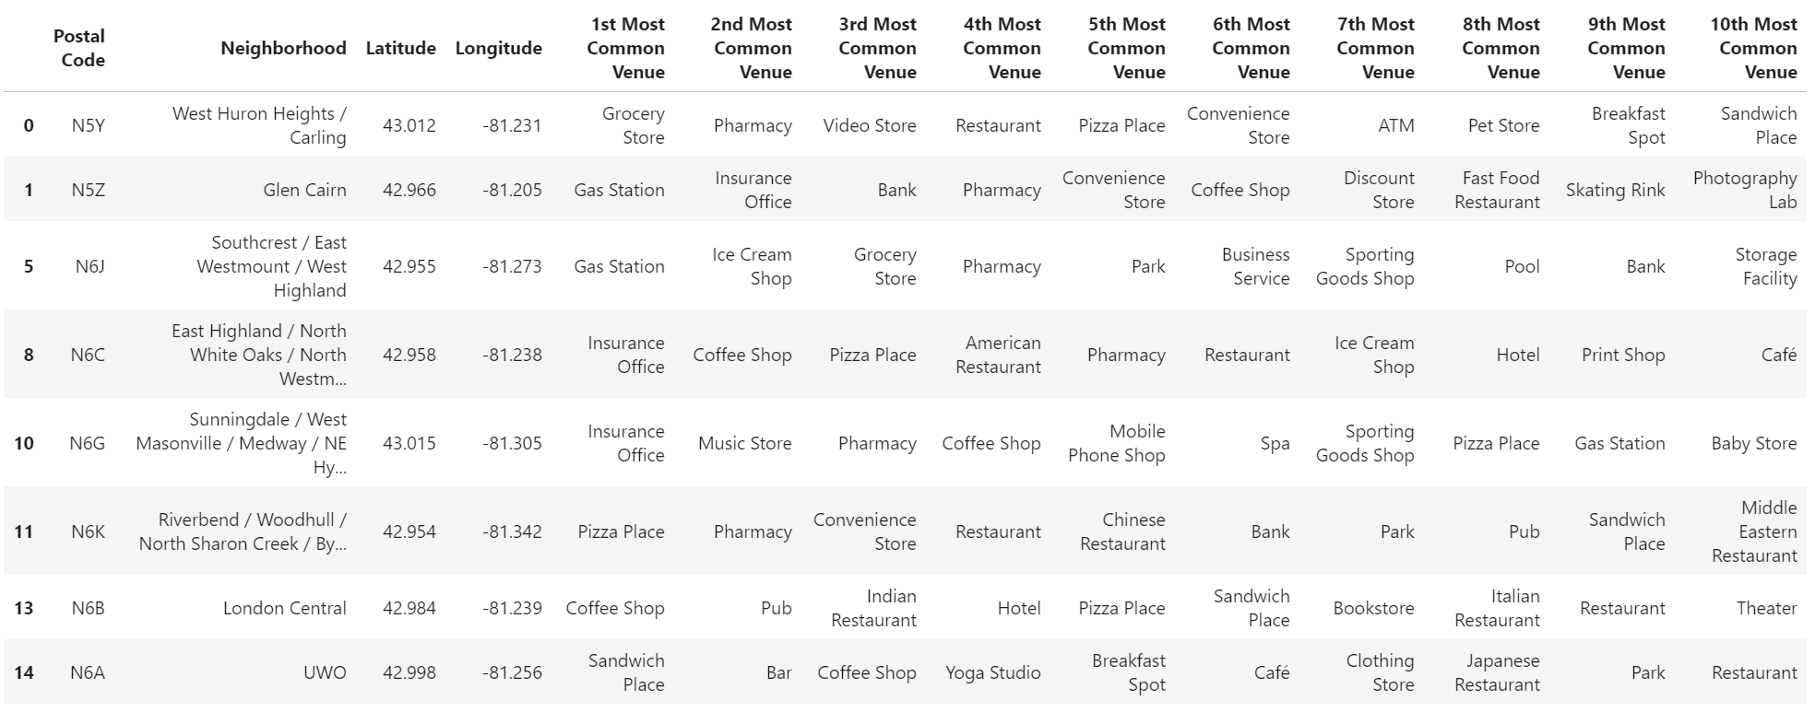

* Currently, the prospective candidates have been determined. In the next step, I will carry out a thorough candidate analysis so that the upsides and downsides of each candidate will be listed out. Visualizing the local venues of each neighborhood on a geographical map will boost the analytical efficiency.

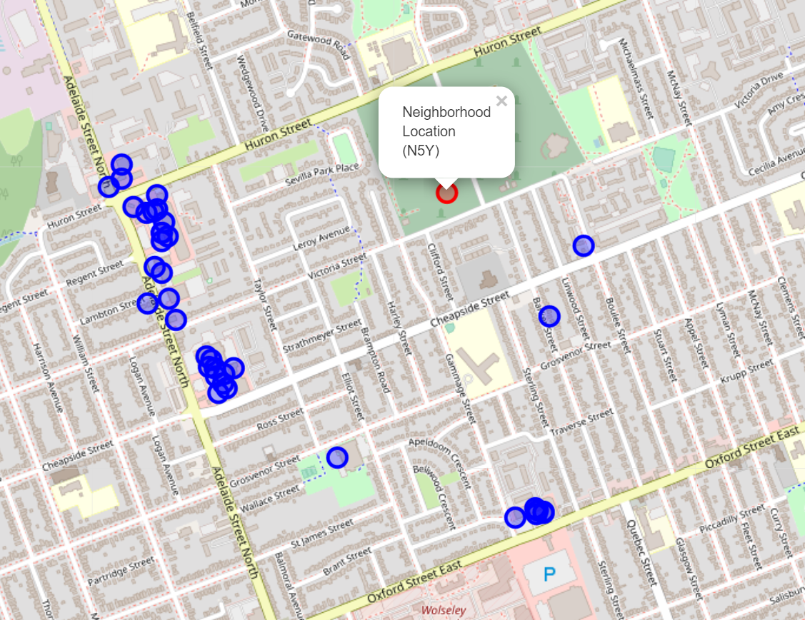 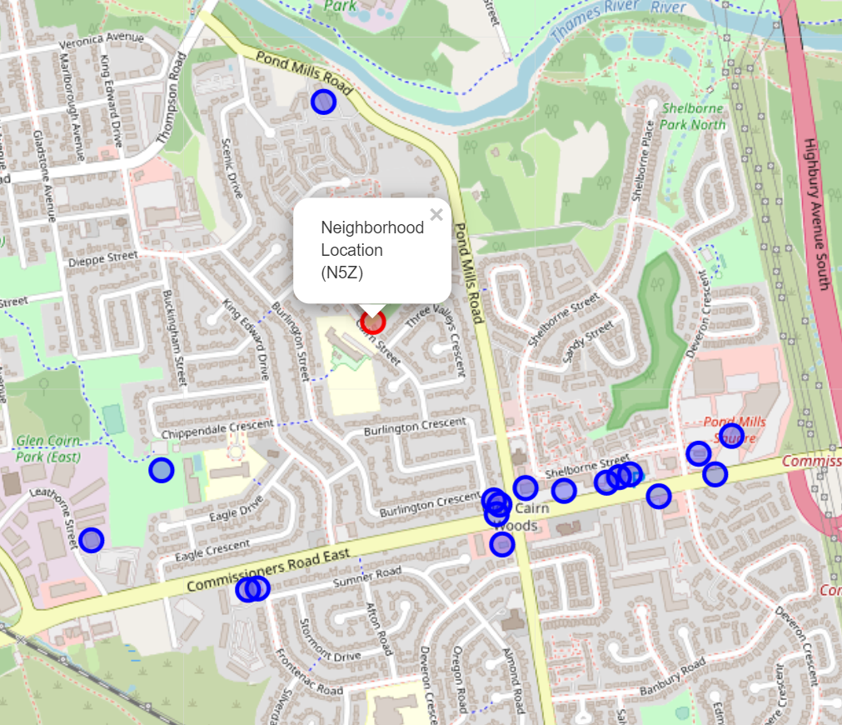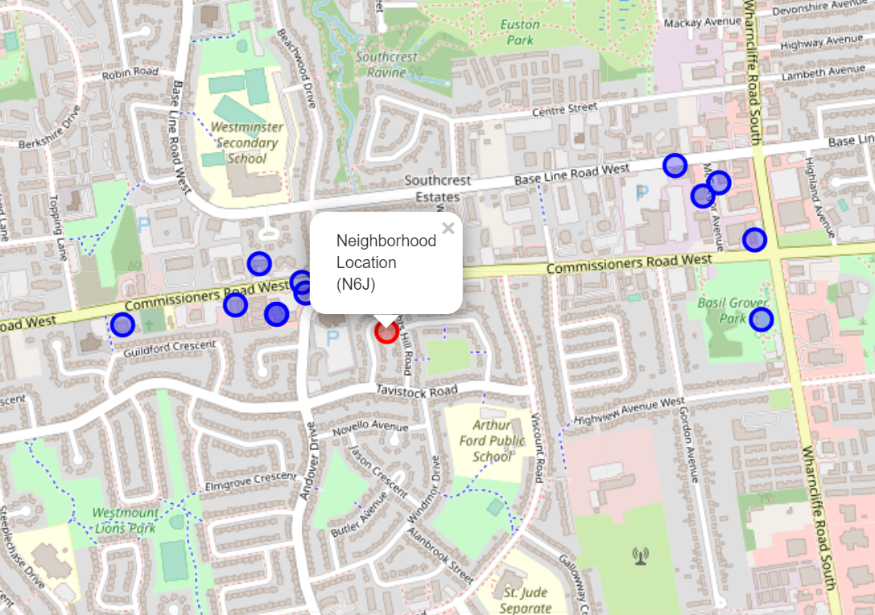 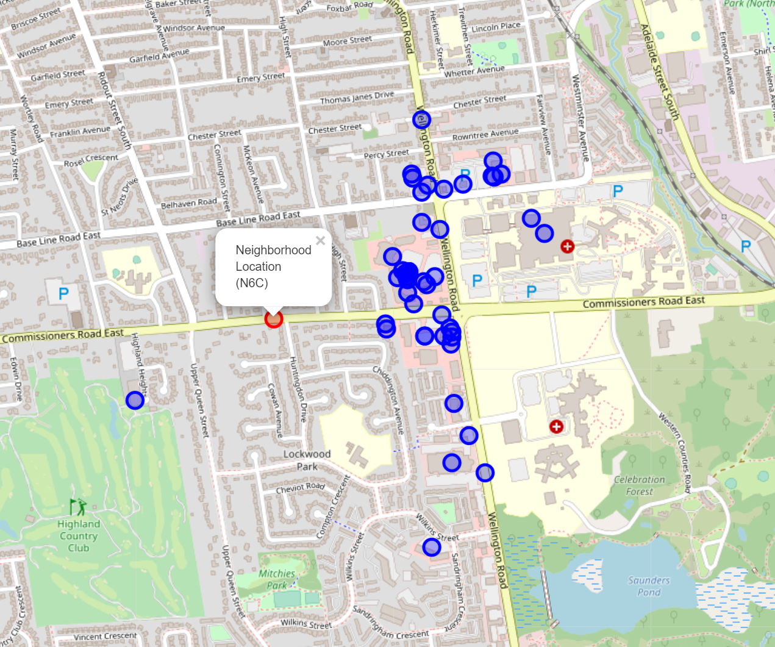

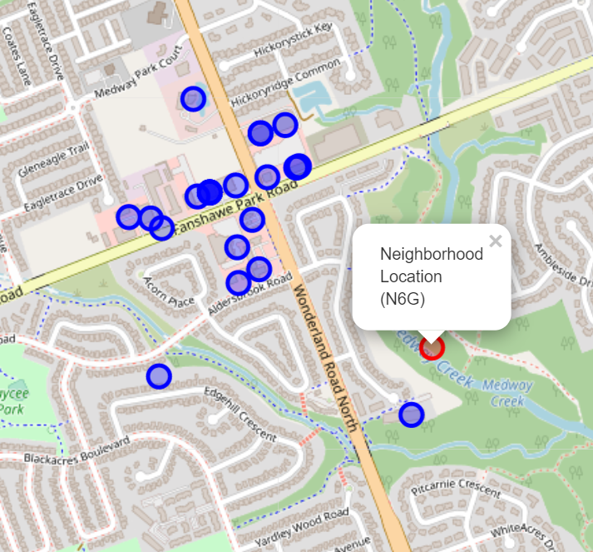 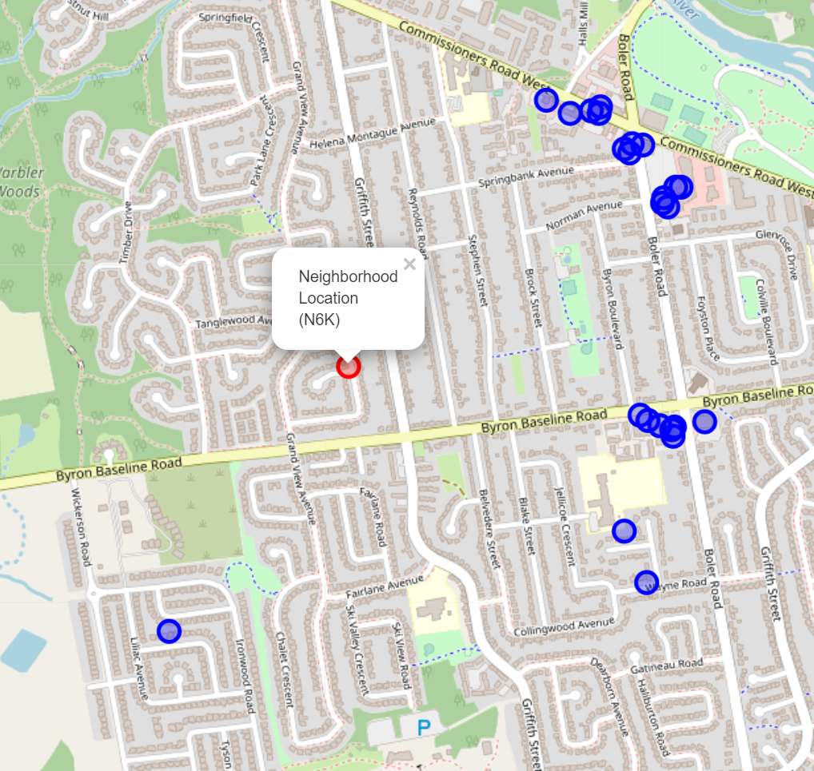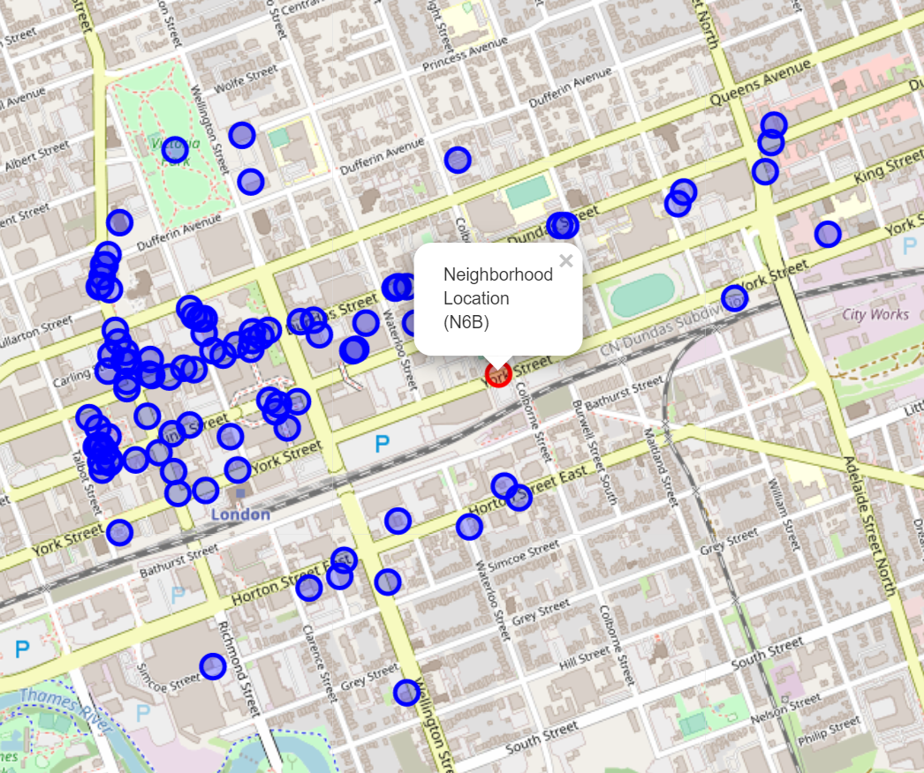 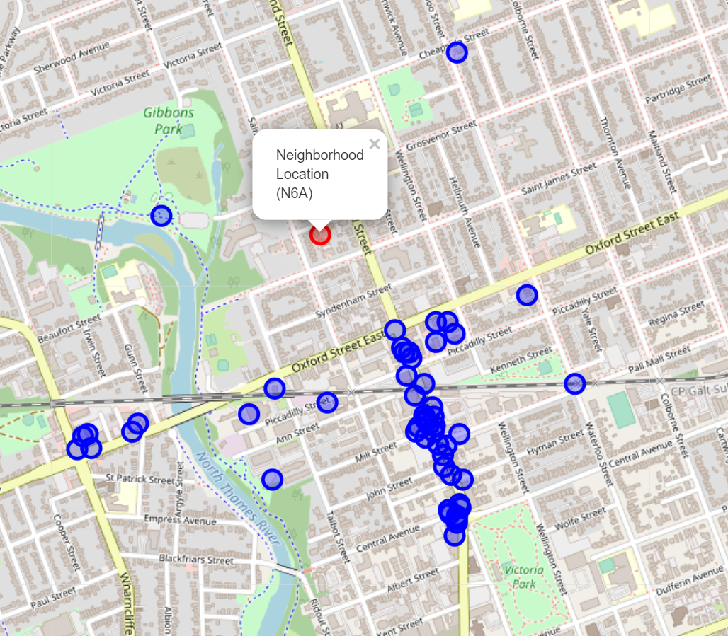

* What needed to concentrate on:
* The distribution of venue categories within a neighborhood.
* How dense the number of venues in one neighborhood should be.
* The proximity between the venues and their neighborhood.
* If visually looking at the geographical map of different neighborhoods above, it is feasible to point out that N6B is densely surrounded by the local venues. This candidate is exactly the living area that the stakeholders are looking forward to inhabiting.
* Nonetheless, these visual analyses are not enough to determine the final result since the other potential ones will run the risk of being biased and missed out at the end. Moreover, the visual maps are incapable of showing the total number of various venue categories within a neighborhood and there is no clue or statistical data for the proximity from the venues to the neighborhood’s center. In other words, a more persuasive, realistic, and rational demonstration will be required.
* **Ranking Criteria**
* The top position in the recommendation list should start with the candidate that shows the diversity of venue categories and is densely surrounded by venues within the area.
* The candidate should be also close to different venues within the radius of 1000 meters from the center of neighborhood.
  1. **2D Cartesian distance calculation and venue category distribution.**
* By applying the 2D cartesian coordinate (x, y) instead of spherical coordinates (latitude, longitude), it is totally easy to calculate the distance from the venues to their neighborhood’s center.
* Firstly, the latitude and longitude of each neighborhood will be converted into x, and y and this mathematic task can be perfectly done by calling the “pyproj” module in Python. Again, the concern about how to technically perform these coordinate transformations even using “pyproj” module will certainly not be interpreted here. Having all the 2D Cartesian coordinate will benefit the distance computation from the venues to the central neighborhood.

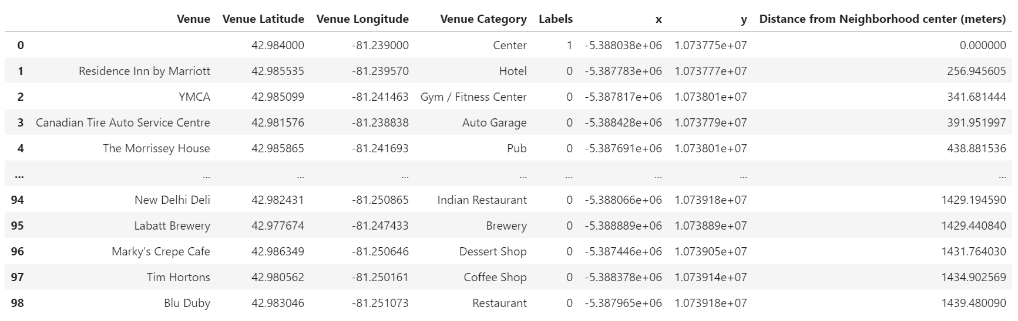

* **Distance formula: $d= \sqrt{{(x^{2}-x^{1})}^{2}+{(y^{2}-y^{1})}^{2} }$**
* All the required distances can be mathematically computed by applying the basic distance formula. These distances will be classified and only the ones which are within 1000 meters are accumulated for the later analysis. Besides, as listed in the “Ranking Criteria”, only the neighborhoods having a variety of venue categories will be qualified, so let gather this requisite data.

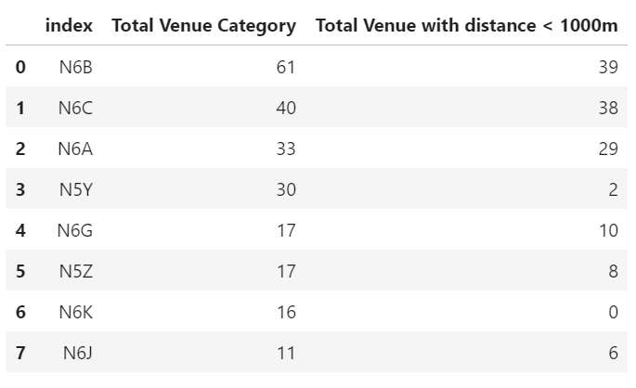

* This will be the complete table for the final analysis. It is not too unexpected when the neighborhood with postal code, N6B is on the top rank, which is plausible because it is actually the London Central where takes place the primary economic activities in London city. In the next sub-section, the more detailed analysis about each individual neighborhood will be clearly stated out.
  1. **Candidate Analysis**
* **Neighborhood analysis**
* **\*\*1. N6B\*\***
* 1st candidate
* Total Venue Category: 63
* Total Venue with distance < 1000m: 40
* **Personal Evaluation:** abundant quantity in venue categories. As shown by the geographical map, the distribution of venue categories is greatly dense within the neighborhood of N6B. It is significant that N6B is the center of London city in Ontario, so it is absolutely a decent and top-notch living area to settle down in the future because it has perfectly met all of the requisite criteria.
* **\*\*2. N6C\*\***
* 2nd candidate
* Total Venue Category: 42
* Total Venue with distance < 1000m: 39
* **Personal Evaluation:** diverse quantity in venue categories. The second recommendation ought to be N6C. Although N6C does not have as many venue categories as N6B, it is still a well-located area for the stakeholders whose budget is restricted. It is quite obvious that the cost of living in an area being further from the central area tend to be cheaper.
* **\*\*3. N6A\*\***
* 3rd candidate
* Total Venue Category: 29
* Total Venue with distance < 1000m: 24
* **Personal Evaluation:** Moderate quantity in venue categories. Overall, N6A has a restriction in venue categories (only 29), but one of its striking features is that there are up to 24 venues which are close to the local center (red point), which enables local inhabitants to save money for transportation.
* **\*\*4. N5Y\*\***
* 4th candidate
* Total Venue Category: 29
* Total Venue with distance < 1000m: 2
* **Personal Evaluation:** Moderate quantity in venue categories. Although both N5Y and N6A have the same number of venue categories, most of the venues' distances within N5Y are greater than 1000 meter(s) since we are trying our best to maximize the proximity. This tend to create a number of hindrances for the elderly or children who are not car owners or have to deal with traffic problems. In general, N5Y is still considered as a trustworthy area to live.
* **\*\*5. N6G\*\***
* 5th candidate
* Total Venue Category: 17
* Total Venue with distance < 1000m: 10
* **Personal Evaluation:** Sparse quantity in venue categories. N6G do not has different types of venue, but it can still provide the local inhabitants with basic daily supplement.
* **\*\*6. N5Z\*\***
* 6th candidate
* Total Venue Category: 17
* Total Venue with distance < 1000m: 8
* **Personal Evaluation:** Sparse quantity in venue categories. There is nothing much different between N6G and N5Z.
* **\*\*7. N6K\*\***
* 7th candidate
* Total Venue Category: 16
* Total Venue with distance < 1000m: 0
* **Personal Evaluation:** Sparse quantity in venue categories. N6K is the only neighborhood which has the worst proximity between venues and the center of their neighborhood.
* **\*\*8. N6J\*\***
* 8th candidate
* Total Venue Category: 11
* Total Venue with distance < 1000m: 6
* **Personal Evaluation:** poor venue categories. An inferior candidate among the others.
* **Neighborhood to neighborhood analysis**
* In case, the stakeholders cannot afford their accommodation in a cosmopolitan and bustling areas like London Central, they definitely have another alternative choice. Specifically, the cost of real estate or even housing price are completely changeable in different local areas. The cost of living near the city center will prohibitively expensive because of high standard of living, but isolating from the center will greatly help stakeholders save a bunch of money. Obviously, the greater distance from the center, the cheaper the living expense will be.
* Observing the geographical maps of the every-single area, it is noticeable that N6B is greatly crowded in venues distribution and the proximity between the neighborhood center (in red) and its venues is great. Therefore, this candidate will be chosen as the central base to measure the distance among the other neighborhoods.

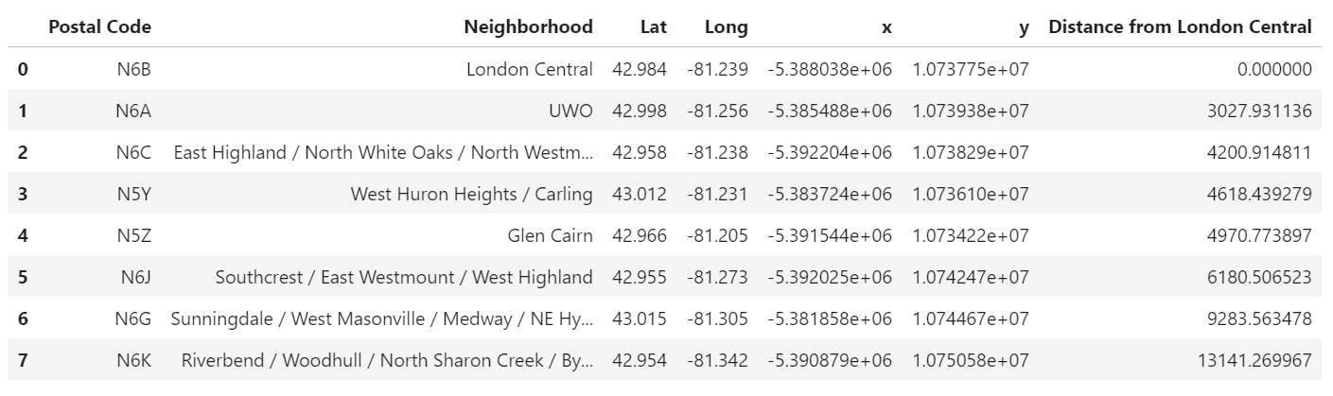

* Distance from UWO to London Central = 3.03km
* Distance from East Highland / North White Oaks / North Westminster to London Central = 4.2 km
* Distance from West Huron Heights / Carling to London Central = 4.62km
* Distance from Glen Cairn to London Central = 4.97km
* Distance from Southcrest / East Westmount / West Highland to London Central = 6.18km
* Distance from Sunningdale / West Masonville / Medway / NE Hyde Park / East Fox Hollow to London Central = 9.28km
* Distance from Riverbend / Woodhull / North Sharon Creek / Byron / West Westmount to London Central = 13.14km
* These calculations indicate the computed distances from each individual neighborhood to London Central. Based on this calculation, the stakeholders will have a second optional choice for their future inhabitation and the final decision can be made.

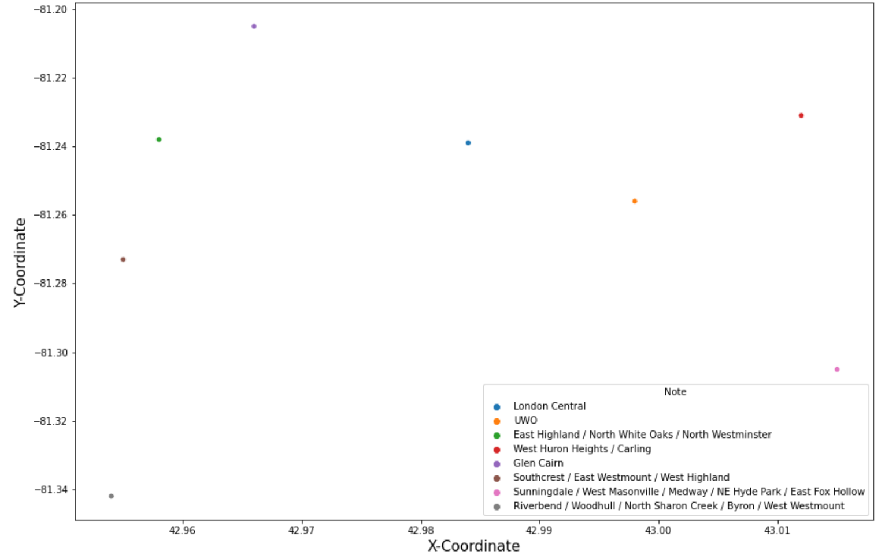

* The scatter plot above just illustrates the location of each neighborhood in 2D Cartesian coordinate in order to give the stakeholders a visual observation of how far the neighborhoods will be from each other.
  1. **Recommendation**

1. **Result and Discussion**
2. **Conclusion**

**Reference**